**Step-1**: Identifying the Entities Required

I have to develop a Human Resource Management database for a company. It requires that you have to add some information of **departments,** **employees** and **projects** including company. As mentioned that every department has many employees and each employee work for a department and each department is leading by only one manager who is also an employee. Initially a new department need not have any employee. Here, though an employee belongs a department but they can work for different projects at the same time. Each employee can work for different job position like Developer, Programmer and front-end designer.

**Step-2:** Identifying the Attributes and Primary key for each Entity

1. department (**id**, name, location, phone_number)
2. employee (**id**, name, email, dob, address, gender, designation, salary, joining_date, department_id)
3. project (**id**, name, description)

**Step-3**: Identifying the Relationship needed

1. employee- works for- department
2. employee -manages- department
3. employee- works for-project
4. department -controls -project
5. Employee- develop- project
6. Employee-programming-project
7. Employee-design-project

**Step-4**: Identifying the Cardinality Ratio and Participation

1. employee- work_for- department

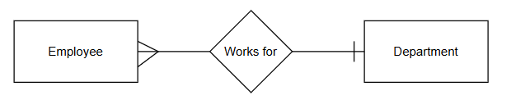

2.employee -manages- department

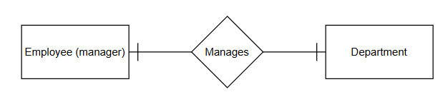

3.employee- work_on -project

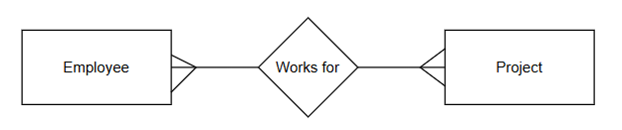

4.department -controls -project

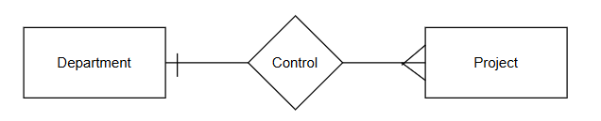

5. employee- develop- project

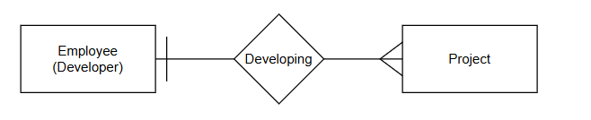

6. Employee-programming-project

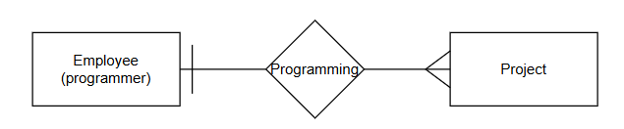

8.Employee-design-project

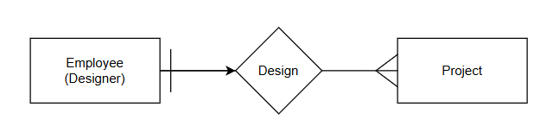

Step-5: Draw the diagram

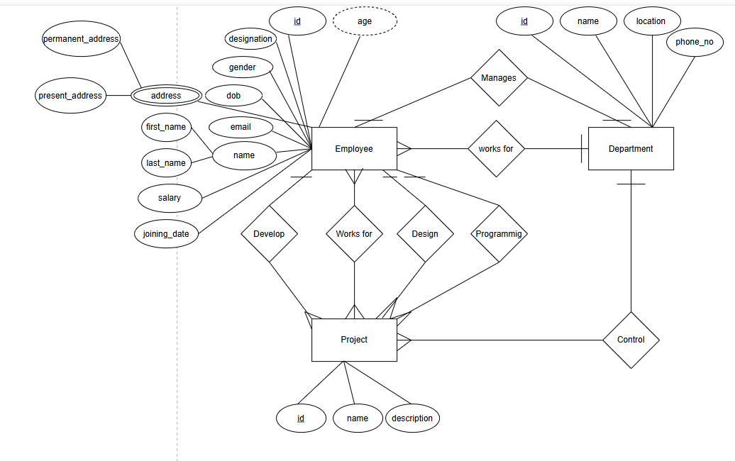

**Step-6**: Reduction to database schema:

1. department (**id**, name, location, phone_number)
2. employee (**id**, name, email, dob, address, gender, designation, salary, joining_date, department_id)
3. project (**id**, name, description, department_id )
4. manager (**id**, employee_id, department_id, start_date, end_date)
5. developer (id, employee_id, department_id, start_date, end_date )
6. programmer (id, employee_id, department_id, start_date, end_date)
7. designer (id, employee_id, department_id, start_date, end_date)
8. phone (**id**, phone_number, employee_id)
9. address (**id**, employee_id, present_address, permanent_address)
10. employee_project (**id**, project_id, employee_id)